

**MPLS L3 VPN CONFIGURATION**

IPNET INSTITUTE OF TECHNOLOGY

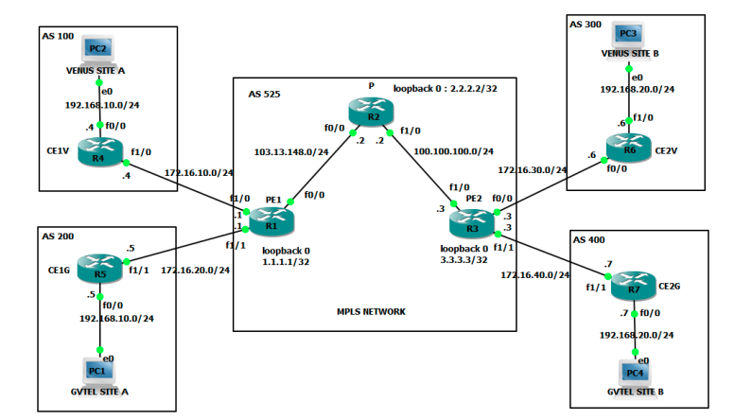

**MPLS L3 VPN CONFIGURATION**

**In our scenario**

* Service provider router P is the ISP core routers, run only MPLS
* Provider edge routers PE1 and PE2 connect to customer sites Venus and Gvtel
* Customer edge routers are at the edge of a customer site; they have no VPN
* awareness
* IGP like OSPF is running on P and PE routers to support LDP and BGP adjacencies
* within the provider network
* MP-BGP is running only PE routers
* eBGP is running between CE and upstream PE routers

**Topologie réalisée**

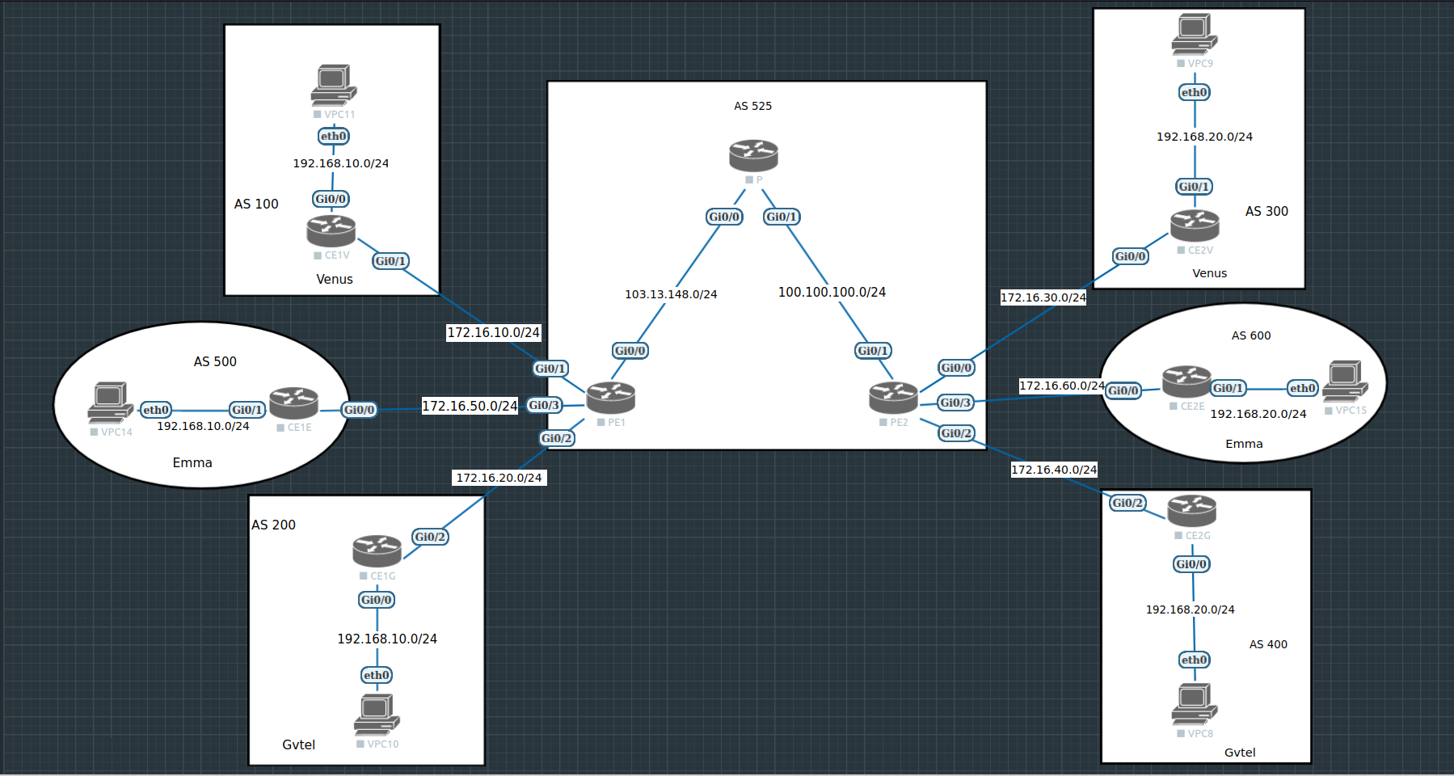

**Configuration**

**P#sh run**

**Building configuration...**

**!**

**! Last configuration change at 00:07:42 UTC Wed Mar 16 2022**

**!**

**hostname P**

**!**

**interface Loopback0**

**ip address 2.2.2.2 255.255.255.255**

**!**

**interface GigabitEthernet0/0**

**ip address 103.13.148.2 255.255.255.0**

**duplex auto**

**speed auto**

**media-type rj45**

**mpls ip**

**!**

**interface GigabitEthernet0/1**

**ip address 100.100.100.2 255.255.255.0**

**duplex auto**

**speed auto**

**media-type rj45**

**mpls ip**

**!**

**router ospf 1**

**network 2.2.2.2 0.0.0.0 area 0**

**network 100.100.100.2 0.0.0.0 area 0**

**network 103.13.148.2 0.0.0.0 area 0**

**!**

**end**

**P#**

**PE1#sh run**

**Building configuration...**

**!**

**! Last configuration change at 02:16:46 UTC Wed Mar 16 2022**

**!**

**!**

**hostname PE1**

**!**

**!**

**ip vrf Emma**

**rd 525:3**

**route-target export 525:3**

**route-target import 525:3**

**!**

**ip vrf Gvtel**

**rd 525:2**

**route-target export 525:2**

**route-target import 525:2**

**!**

**ip vrf Venus**

**rd 525:1**

**route-target export 525:1**

**route-target import 525:1**

**!**

**!**

**interface Loopback0**

**ip address 1.1.1.1 255.255.255.255**

**!**

**interface GigabitEthernet0/0**

**ip address 103.13.148.1 255.255.255.0**

**duplex auto**

**speed auto**

**media-type rj45**

**mpls ip**

**!**

**interface GigabitEthernet0/1**

**ip vrf forwarding Venus**

**ip address 172.16.10.1 255.255.255.0**

**duplex auto**

**speed auto**

**media-type rj45**

**mpls ip**

**!**

**interface GigabitEthernet0/2**

**ip vrf forwarding Gvtel**

**ip address 172.16.20.1 255.255.255.0**

**duplex auto**

**speed auto**

**media-type rj45**

**mpls ip**

**!**

**interface GigabitEthernet0/3**

**ip vrf forwarding Emma**

**ip address 172.16.50.1 255.255.255.0**

**duplex auto**

**speed auto**

**media-type rj45**

**mpls ip**

**!**

**router ospf 1**

**network 1.1.1.1 0.0.0.0 area 0**

**network 103.13.148.1 0.0.0.0 area 0**

**!**

**router bgp 525**

**bgp log-neighbor-changes**

**neighbor 3.3.3.3 remote-as 525**

**neighbor 3.3.3.3 update-source Loopback0**

**neighbor 172.16.10.4 remote-as 100**

**neighbor 172.16.20.5 remote-as 200**

**neighbor 172.16.50.8 remote-as 500**

**!**

**address-family vpnv4**

**neighbor 3.3.3.3 activate**

**neighbor 3.3.3.3 send-community extended**

**exit-address-family**

**!**

**address-family ipv4 vrf Emma**

**neighbor 172.16.50.8 remote-as 500**

**neighbor 172.16.50.8 activate**

**exit-address-family**

**!**

**address-family ipv4 vrf Gvtel**

**neighbor 172.16.20.5 remote-as 200**

**neighbor 172.16.20.5 activate**

**exit-address-family**

**!**

**address-family ipv4 vrf Venus**

**neighbor 172.16.10.4 remote-as 100**

**neighbor 172.16.10.4 activate**

**exit-address-family**

**!**

**!**

**end**

**PE1#**

**PE2#sh run**

**Building configuration...**

**!**

**! Last configuration change at 02:15:38 UTC Wed Mar 16 2022**

**!**

**hostname PE2**

**!**

**ip vrf Emma**

**rd 525:3**

**route-target export 525:3**

**route-target import 525:3**

**!**

**ip vrf Gvtel**

**rd 525:2**

**route-target export 525:2**

**route-target import 525:2**

**!**

**ip vrf Venus**

**rd 525:1**

**route-target export 525:1**

**route-target import 525:1**

**!**

**!**

**interface Loopback0**

**ip address 3.3.3.3 255.255.255.255**

**!**

**interface GigabitEthernet0/0**

**ip vrf forwarding Venus**

**ip address 172.16.30.3 255.255.255.0**

**duplex auto**

**speed auto**

**media-type rj45**

**mpls ip**

**!**

**interface GigabitEthernet0/1**

**ip address 100.100.100.3 255.255.255.0**

**duplex auto**

**speed auto**

**media-type rj45**

**mpls ip**

**!**

**interface GigabitEthernet0/2**

**ip vrf forwarding Gvtel**

**ip address 172.16.40.3 255.255.255.0**

**duplex auto**

**speed auto**

**media-type rj45**

**mpls ip**

**!**

**interface GigabitEthernet0/3**

**ip vrf forwarding Emma**

**ip address 172.16.60.3 255.255.255.0**

**duplex auto**

**speed auto**

**media-type rj45**

**mpls ip**

**!**

**router ospf 1**

**network 3.3.3.3 0.0.0.0 area 0**

**network 100.100.100.3 0.0.0.0 area 0**

**!**

**router bgp 525**

**bgp log-neighbor-changes**

**neighbor 1.1.1.1 remote-as 525**

**neighbor 1.1.1.1 update-source Loopback0**

**neighbor 172.16.30.6 remote-as 300**

**neighbor 172.16.40.7 remote-as 400**

**neighbor 172.16.60.9 remote-as 600**

**!**

**address-family vpnv4**

**neighbor 1.1.1.1 activate**

**neighbor 1.1.1.1 send-community extended**

**exit-address-family**

**!**

**address-family ipv4 vrf Emma**

**neighbor 172.16.60.9 remote-as 600**

**neighbor 172.16.60.9 activate**

**exit-address-family**

**!**

**address-family ipv4 vrf Gvtel**

**neighbor 172.16.40.7 remote-as 400**

**neighbor 172.16.40.7 activate**

**exit-address-family**

**!**

**address-family ipv4 vrf Venus**

**neighbor 172.16.30.6 remote-as 300**

**neighbor 172.16.30.6 activate**

**exit-address-family**

**!**

**!**

**end**

**PE2#**

**CE1V#sh run**

**Building configuration...**

**!**

**! Last configuration change at 05:43:46 UTC Wed Mar 16 2022**

**!**

**hostname CE1V**

**!**

**!**

**interface GigabitEthernet0/0**

**ip address 192.168.10.4 255.255.255.0**

**duplex auto**

**speed auto**

**media-type rj45**

**!**

**interface GigabitEthernet0/1**

**ip address 172.16.10.4 255.255.255.0**

**duplex auto**

**speed auto**

**media-type rj45**

**!**

**router bgp 100**

**bgp log-neighbor-changes**

**network 192.168.10.0**

**neighbor 172.16.10.1 remote-as 525**

**!**

**end**

**CE1V#**

**CE2V#sh run**

**Building configuration...**

**!**

**! Last configuration change at 05:47:04 UTC Wed Mar 16 2022**

**!**

**hostname CE2V**

**!**

**interface GigabitEthernet0/0**

**ip address 172.16.30.6 255.255.255.0**

**duplex auto**

**speed auto**

**media-type rj45**

**!**

**interface GigabitEthernet0/1**

**ip address 192.168.20.6 255.255.255.0**

**duplex auto**

**speed auto**

**media-type rj45**

**!**

**router bgp 300**

**bgp log-neighbor-changes**

**network 192.168.20.0**

**neighbor 172.16.30.3 remote-as 525**

**!**

**!**

**end**

**CE2V#**

**CE1E#sh run**

**Building configuration...**

**!**

**!**

**hostname CE1E**

**!**

**interface GigabitEthernet0/0**

**ip address 172.16.50.8 255.255.255.0**

**duplex auto**

**speed auto**

**media-type rj45**

**!**

**interface GigabitEthernet0/1**

**ip address 192.168.10.8 255.255.255.0**

**duplex auto**

**speed auto**

**media-type rj45**

**!**

**router bgp 500**

**bgp log-neighbor-changes**

**network 192.168.10.0**

**neighbor 172.16.50.1 remote-as 525**

**!**

**!**

**end**

**CE1E#**

**CE2E#sh run**

**Building configuration...**

**!**

**!**

**hostname CE2E**

**!**

**!**

**interface GigabitEthernet0/0**

**ip address 172.16.60.9 255.255.255.0**

**duplex auto**

**speed auto**

**media-type rj45**

**!**

**interface GigabitEthernet0/1**

**ip address 192.168.20.9 255.255.255.0**

**duplex auto**

**speed auto**

**media-type rj45**

**!**

**router bgp 600**

**bgp log-neighbor-changes**

**network 192.168.20.0**

**neighbor 172.16.60.3 remote-as 525**

**!**

**!**

**end**

**CE2E#**

**CE1G#sh run**

**Building configuration...**

**!**

**hostname CE1G**

**!**

**!**

**interface GigabitEthernet0/0**

**ip address 192.168.10.5 255.255.255.0**

**duplex auto**

**speed auto**

**media-type rj45**

**!**

**interface GigabitEthernet0/2**

**ip address 172.16.20.5 255.255.255.0**

**duplex auto**

**speed auto**

**media-type rj45**

**!**

**router bgp 200**

**bgp log-neighbor-changes**

**network 192.168.10.0**

**neighbor 172.16.20.1 remote-as 525**

**!**

**!**

**end**

**CE1G#**

**CE2G#sh run**

**Building configuration...**

**!**

**hostname CE2G**

**!**

**!**

**interface GigabitEthernet0/0**

**ip address 192.168.20.7 255.255.255.0**

**duplex auto**

**speed auto**

**media-type rj45**

**!**

**interface GigabitEthernet0/2**

**ip address 172.16.40.7 255.255.255.0**

**duplex auto**

**speed auto**

**media-type rj45**

**!**

**!**

**router bgp 400**

**bgp log-neighbor-changes**

**network 192.168.20.0**

**neighbor 172.16.40.3 remote-as 525**

**!**

**!**

**end**

**CE2G#**

**VPC11> ip 192.168.10.10/24 gateway 192.168.10.4**

**VPC9> ip 192.168.20.10/24 gateway 192.168.20.6**

**VPC14> ip 192.168.10.11/24 gateway 192.168.10.5**

**VPC15> ip 192.168.20.11/24 gateway 192.168.20.7**

**VPC10> ip 192.168.10.20/24 gateway 192.168.10.8**

**VPC8> ip 192.168.20.20/24 gateway 192.168.20.9**

**Quelques tests en images**

* **Ping entre le site Venus(AS100) et Venus(AS300)**

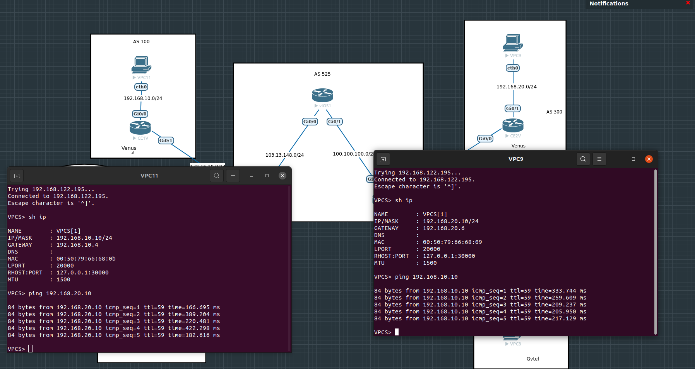

* **Ping entre le site Emma(AS500) et Emma(AS600)**

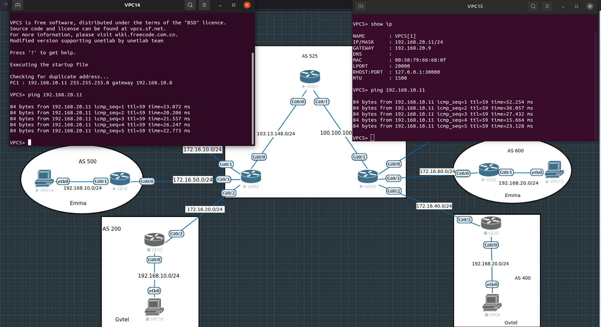

* **Ping entre le site Gvtel(AS200) et Gvtel(AS400)**

